**Flash Manager (Library Management System)**



**Name:** Muhammad Usama **Name:** Fizza Asghar

**Session:** 2021-2023 **Session:** 2021-2023

**Roll No:** S21RDOCS2M01078 **Roll No:** S21RDOCS2M01071

**DEPARTMENT OF COMPUTER SCIENCE**

**Islamia University Bahawalpur RYK-Campus**

Under the Supervision Of**:**

**MIRZA ADNAN BAIG**

**By:**

**Name:** Muhammad Usama **Name:** Fizza Asghar

**Session:** 2021-2023 **Session:** 2021-2023

**Roll No:** S21RDOCS2M01078 **Roll No:** S21RDOCS2M01071

**A DISSERTATION SUBMITTED TO**

**DEPARTMENT OF COMPUTER SCIENCE**

**Islamia University Bahawalpur RYK-Campus**

**DECLARATION**

We Muhammad Usama Roll No.S21RDOCS2M01078, Fizza Asghar Roll No.S21RDOCS2M01078 Students of Masters in Computer Science (M.C.s) in the subject of Computer Science Session 2021-2023, hereby declare that the matter printed in the thesis titled **Flash Manager LMS** is our own work and has not been printed, published and submitted as research work, thesis or publication in any form in any University or Research Institution in Pakistan or abroad.

Dated



**ACKNOWLEDGEMENT**

We would like to express our special thanks of gratitude to our teacher **Mirza Adnan Baig** who gave us the golden opportunity to do this wonderful project on **Library Management System**, which also helped us in doing a lot of Research.

Secondly, we also thankful to our families and friends who helped us in this project and we able to finalize this project within the limited time.

We particularly grateful to the Almighty Allah for granting us the opportunity to undertake this research work. My words of special thanks to **Dr. Qaiser Shaheen (HOD)** Head of Department of Computer Science for his guidance and support. Next we want to say special thanks to **Mirza Adnan Baig**, our research supervisor who played a major role in fulfillment of this thesis, without their valuable direction this might be an impossible for us.

We are remembering the whole MCS 2021 batch, in accompany to whom we set in an academic journey, which is being conclude now. Thank you for being there, our dear fellows.

We are out of justifiable words to stretch our thanks to our commendable parents.

**PROJECT COMPLETION CERTIFICATE**

It is certified that the Project contained in this SDD titled **LIBRARY MANAGEMENT SYSTEM WEB BASED APPLICATION** has been carried out and completed by Muhammad Usama & Fizza Asghar.

**Dated Supervisor’s Signature**

**Submitted Through**

**Dr.___________________________________ Controller of Examination**

**Director Islamia University BWP**

**Department Of Computer Science**

**Revision History**

|  |  |  |  |
| --- | --- | --- | --- |
| **Date** | **Description** | **Author** | **Comments** |
| 04-10-2022 | Version 1.1 | Muhammad Usama, Fizza Asghar | 1st Revision |
| 11-10-2022 | Version 1.2 | Muhammad Usama, Fizza Asghar | 2nd Revision |
| 18-10-2022 | Version 1.3 | Muhammad Usama, Fizza Asghar | 3rd Revision |
| 25-10-2022 | Version 1.4 | Muhammad Usama, Fizza Asghar | 4th Revision |
| 01-11-2022 | Version 1.5 | Muhammad Usama, Fizza Asghar | 5th Revision |
| 08-11-2022 | Version 2.0 | Muhammad Usama, Fizza Asghar | Final Revision |

**Document Approval**

The following Software Requirements Specification has been accepted and approved by the following:

|  |  |  |  |
| --- | --- | --- | --- |
| **Signature** | **Name** | **Title** | **Date** |
|  | Sir Mirza Adnan Baig | Supervisor, CSIT 21407 |  |

**Abstract:**

Library management is a project that manages and stores books information electronically according to student’s needs. The system helps both students and library manager to keep a constant track of all the books available in the library. It allows both the admin and the student to search for the desired book.

The aim is to automate its existing manual system with the help of computerized equipment and full-fledged computer software, fulfilling their requirements, so that their valuable data/information can be stored for a longer period with easy access and manipulation of the same. Basically, the project describes how to manage for good performance and better services for the clients.

This Web-Based Application **Flash Manager (Library Management System LMS)** will contain admin login page in which admin can control the whole site and provide services to the users of the website.

This Library Management System (LMS) gives access to and manages the resources in your library.​ A well-chosen system will increase your library’s efficiency, save valuable administration time, lead to a better educational experience for pupils and help develop independent learning.

**Table of Contents**

**1 Introduction**………………………………………………………………

* 1. Project Aims and Objectives …………………………………………

1.2 Purpose of System…………………………………………………..

1.3 System Scope…………………………………………

1.4 System Overview……………………………….

* 1. Technical Approach…………………………….
     1. Identifying Customer Needs…………………………
     2. Generating Design Concepts………..
     3. Project Management…………………..
     4. Deliverables………………………………….
  2. Conclusions…………………………………..

1.7 Previous Works……………………………….

1.8 References……………………………..

**2 System Overview**………………………

2.1 Effected Groups…………………………..

**3 System Design**………………………………

3.1 Process model………………………………….

3.1.1 Prescriptive Process Model…………………….

3.1.2 Selecting Our Process Model……………………….

3.1.3Why Not Used Water Fall Model……………………….

3.2 Our Selected Approach…………………………….

3.2.1Agile DevelopmentModel………………………….

3.3 Requirements Engineering………………………..

3.4 Functional Requirements…….

3.4.1 Admin Level…………….

3.4.2 User Level……………………….

3.4.3 Other……………………..

3.5 Data Description…….…………….

3.6 System Actors………………….

3.7 UML Diagrams………………………………..

3.4.1 ER-Diagram………………………………………….

3.4.2 Use Case Diagrams………………………………………….

3.4.3 Sequence Diagram………………………………………….

3.4.4 Activity Diagram………………………………………….

3.4.5 Collaboration Diagram ………………………………………….

3.4.6 State Diagram ………………………………………….

3.4.7 Data Flow Diagram ………………………………………….

**4 Implementation**…………………………………….

4.1 Tools/Technology Used……………………………….

4.2 Hardware and Software Requirements……………..

4.2.1 Hardware Requirements……………………

4.2.2 Software Requirements……………………

4.3 Project Screenshots…………………………….

**1**

**Introduction:**

**1.1 PROJECT AIMS AND OBJECTIVES**

The project aims and objectives that will be achieved after completion of this project are discussed in this subchapter. The aims and objectives are as follows:

* Online book issue
* Request column for librarian for providing new books
* A separate column for digital library.
* Student login page where student can find books issued by him/her and date of return.
* A search column to search availability of books
* A teacher login page where teacher can add any events being organized in the college and important suggestions regarding books.

**1.2 PURPOSE OF SYSTEM**

Library Management System is an application which refers to library systems which are generally small or medium in size. It is used by librarian to manage the library using a computerized system where he/she can record various transactions like issue of books, return of books, addition of new books, addition of new students etc. Books and student maintenance modules are also included in this system which would keep track of the students using the library and also a detailed description about the books a library contains. With this computerized system there will be no loss of book record or member record which generally happens when a non-computerized system is used.

In addition, report module is also included in Library Management System. If user’s position is

Admin, the user is able to generate different kinds of reports like lists of students registered, list of books, issue and return reports. All these modules are able to help librarian to manage the library with more convenience and in a more efficient way as compared to library systems which are not computerized.

**1.3 SYSTEM SCOPE**

* Any education institute can make use of it for providing information about author, content of the available books.
* It can be used in offices and modifications can be easily done according to requirements

**1.4 SYSTEM OVERVIEW**

Library Management System is an application which refers to library systems. It three user interfaces.

* **Admin Panel**

Admin can access data base, see books, pulishers, authors and categories information , generate reports, control the accounts and handle all kind of customer’s issues.

* **Visitor**

User can visit the website and request for registration to see available books, authors, categories and publishers.

* **Registered Students**

Only registered students can see the details of library like books, authors, pulishers and categories.

**1.5 Technical Approach**

We are using the web platform for the deployment of the system.

Internet is required to access the server. Details are as follow:

* + 1. **Identifying Customer Needs**

Every library user requires a website which can provide him with the best details of books available and authors’ information safely using an online system. It will save his/her time to go outside and physically visiting the library.

**1.5.2 Generating Design Concepts**

We will use the web environment to implement our system.

* + 1. **Selecting Design Concept**

The reason for selecting this environment is that it have large users and being used vastly now a days.

* + 1. **Project Management**

It mainly constitutes the plan that we are intended to follow for the development of our system. We students will work under the supervision of a project supervisor; one of our teacher.

**1.5.4 Deliverables**

Implementation of this web based system will be provided on the web environment. Anywhere access of this web application is possible due to connectivity through the internet.

### 1.6 Conclusion

The project being developed is focused on the aim that common book readers are benefited the most. And this project will be capable of being easily deployed in real time environment. It will work as a real world application. This application will be a bright example of the fact that how can technology affect the daily life and bring about the improved betterment of currently available facilities.

* 1. **Previous Works**

Different types of online library management web applications are there in the market that are providing data about different books and other functionalities. Some of them even providing information about different subjects and topics. It depends on the users’ demand that which kind of web application they want to use.

**1.8 References**

www.google.com

www.w3resource.com

www.stackoverflow.com

www.guru99.com

docs.microsoft.com

**2**

**System Overview:**

Many Library Management web applications are working and providing online library facilities such as reading online books, magazines, references, journals, and much more. People also wants to save their time as well as money. So web applications can help them book mark the websites that they often used to visit. There are rare applications which are providing books addition and other references. So there is a need of such application. But in order to see which work has been done, what is the scope of that work and to which extent it is helpful.

we had to see the working of other library management applications. And so the inspiration for this idea came from fact that how they are using this web technology to help themselves.

Weiner reviewed the literature extant on leadership in academic libraries and surveyed materials on “recruitment, leadership potential identification, career development, roles and responsibilities, and characteristics and management style”

**2.1 Affected Groups**

Libraries of; **Schools, Colleges, Universities**

Technical Resources Management etc

Administrators

* **Assumptions**

All students have computer knowledge

All students have internet access

All Students have gadgets with web browser

* **Dependencies/ External Systems**

Computer/Laptop

Browser Application

Active Internet Connection

* **Privileges**

The administrator of the web-server the Real Estate website is installed on will have sufficient privileges to upload images/files and administrative database access.

**3**

**System Design:**

Process model is the activity that is done by the team before the commencement of requirement gathering which is actually a part of process model.

### 3.1 Process model

Process model is an approach towards the development of an application and it contains the necessary actions and events and all other related data without which the process of building application cannot be completed. Framework is the super entity that contains these events, actions and the whole process. It also defines the how these events are related to each other and are related to the process itself. Every frame work activity consists of software engineering actions. These software engineering actions further contain task sets. Each task set contain action tasks which are meant to be accomplished by the development team. Work products that are going to be delivered by the team, quality assurance tasks and such milestones that will represent the progress of the ongoing project. There are five framework activities: **Communication, Planning, Construction, Modeling** and **Deployment.**

In addition to all these activities, there are some other activities known as the umbrella activitiesthat are carried out from start till end of the software. These activities include Risk Management, Quality Assurance, Project Control and Tracking and the technical reviews etc. There can be different types of process flow for these activities with respect to time and sequence.

**Linear flow** is the one in which the above described activities start from beginning and end at Deployment, this flow is sequential.

**Iterative process flow** includes the repetition of some activities before the process continues to move to the next stage of activities.

**Evolutionary flow** encompasses the circular flow of the activities during the process flow. This is applied for the incremental releases of the software products.

**Parallel flow** depicts the fact that activities are carried out parallel to each other.

**3.1.1 Prescriptive Process Model**

Many prescriptive process models that were proposed to cope with the problems used to occur during the software development. These include Linear Models: Waterfall Model, V-Model (which is a variation of the Waterfall Model), and Parallel Models: Incremental Model and Iterative Model: Spiral Model etc.

**3.1.2 Selecting Our Process Model**

We did not select the prescriptive process models that have been described above. Rather we selected Agile Development Model. There were a number of reasons that we did not selected among the prescriptive models.

**3.1.3 Why Not Used Water Fall Model**

It is quite a linear approach in which activities are carried out in a sequence with respect to time.

This model is adopted if the requirements are very clear. Even though changes to a software system can be made while using this system, but it can only be done while the adaptation requirement are well-understood and clear. It is rare that the customer specify all the requirements before the start of project development explicitly. But the waterfall model requires the clear and full statement of the requirements. Other thing is that it supports iteration but it is done in a vague manner so it does not help much while thinking of implementing iteration.

### 3.2 Our Selected Approach

**3.2.1 Agile Development**

This paradigm was selected due to the reason that we have a small team. We are to deliver the work products (prototypes) to satisfy the user. Our team is having constant communication with the stakeholders which include our particular approach into the category of agile development. Our team is self-organizing which help us to adapt according to the rapidly occurring changes in the environment.

It is to be noted here that agile development does not comprise on the core software process activities i.e. Communication, Planning, Modeling, Construction and Deployment.

There are following elements of the extreme programming process:

* Planning
* Designing
* Coding
* Testing

**Diagram Showing Agile Model**

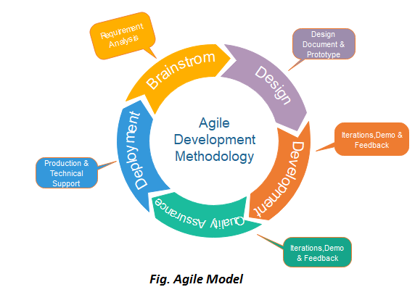

**3.3 Requirements Engineering**

• **Inception:**

People want to access a verity of books and other useful information anytime while staying at home. In this modern era people don’t have much time to go at a physical library and read books so they prefer to have a facility at their phone or laptop. The librarians need to organize record of books they also have to maintain the library by sorting books according to their categories. They need a system to handle and manage all these tasks.

**• Elicitation:**

After eliciting the requirements from the stake holders, following objectives were set be achieved by the system:

1. Make a web application for the mobile users where they can easily go and read books online any time.

2. Application may provide the facility to connect with a desktop computer and user can access it.

**• Elaboration:**

Elaboration of the requirements was made by drawing the scenario based models to show that how the used is supposed to interact with the application.

**• Negotiation:**

Meetings were arranged so that all the stakeholders may negotiate with one another. This was to ensure that all stake holders agree upon set of requirements for a solution that is acceptable for all stakeholders. Some common patients were asked about what would be their views if that sort of application is developed. After getting one agreed set of requirement from the users, the basic idea of an application to be developed was perceived.

**• Specification:**

Prototypes were developed to demonstrate the specification of the application to be developed.

**• Validation:**

Validation of the requirements was achieved by talking to the users and changes were made to the user scenarios and the next prototypes to be developed as requirements were validated. Missing information was collected and clarifications were made.

**• Requirement management:**

Requirement management activities have also been planned to manage the requirements as they change or more requirements are added by the user.

**3.4 Functional Requirements**

Functional requirement are those requirements that define the functionality of project. In other functional requirements are basically how the system works for the users.

Interface of software to provide the interaction between students, admins and teachers.

* **Admin Level**

1. Logging into the system

2. Accepting registration of candidates

3. Adding/editing/deleting the book record

4. Checking Book Availability

5. Issuing Book

6. Restoring Book

7. Information to User

8. Adding/editing/deleting the authors, categories,pulishiers

* **User Level**

1. Requesting registration

2. Logging into the system

3. Selecting the Required Book

4. Requesting for Book Issue

5. Returning the book

**Other Requirements:**

* Only authentic user must have the access to the system.
* Only the user must be able to provide the information related to the library.
* User must be able to:
  + Provide the information regarding books.
  + Search for the required books from database.
  + Add new book to the database.
  + Update the number of books in database.
  + Enter data of issued book in Database.
  + Information of returned books.
* User must have the knowledge about the no of copies of a book.
* Same Id’s for 2 or more books shall not be allowed.
* User must check if the book is available or not before issuing.
* User must enter issue and return date in database.
* The user must know the number of shelves in the library.

**3.5 DATA DESCRIPTION**

**User**

|  |  |  |
| --- | --- | --- |
| Parameter | Type | Description |
| User_id | Int | Uniquely identify |
| Name | Char | Name of user |
| Password | Varchar | Access code of user authentication |
| Email | Varchar | Email of user |
| Address | Varchar | Address of user |
| Phone no | Varchar | Contact no. Of user |

**3.6 System Actors**

* Admin
* User (Brower)
* Library Database

**UseCase**

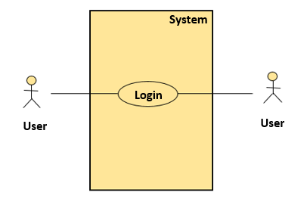

|  |  |
| --- | --- |
| Actor | User |
| Pre-condition | You must create your account first. |
| Post-condition | You are able to access the account. |
| Description | 1. User want to login to do some work 2. User must be entered their username and password to login |

**3.7 UML (Unified Modeling Language) Diagrams**

A Diagram is the most important tool to depict the requirement phase and its better understanding for the users. Therefore, for this purpose many diagrams are drawn to show that how does the system behave and what were the given requirements according to which the project was to be developed. Diagrams are drawn in a suitable manner from the start of the requirement phase till showing the implementation of the required functionality from the system. So there are following types of diagrams that will be used here to tell how the system behaves actually and what were the expected functionalities posed by the user. Here is the list:

• ER-Diagram

• Use Case Diagrams

• Sequence Diagram

• Activity Diagram

• Collaboration Diagram

• State Diagram

• Data Flow Diagram

In the Upcoming Part we will cover those UML diagrams one by one.

UML diagrams can be used as a way to visualize a project before it takes place or as documentation for a project afterward. But the overall goal of UML diagrams is **to allow teams to visualize how a project is or will be working**, and they can be used in any field, not just software engineering.

**ER-Diagram**

Book

Book description

Book author

Book name

Book id

Maintains

Admin

Name

Email

Password

Borrows

Brower/Student

Student name

Student class

Student contact

Student RollNo

**Use Case Diagrams**

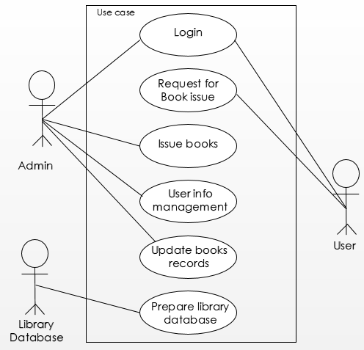

**Sequence Diagram**

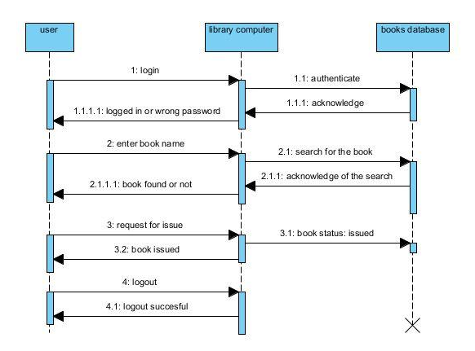

**Activity Diagram**

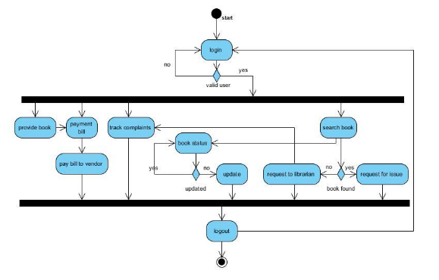

**Collaboration Diagram**

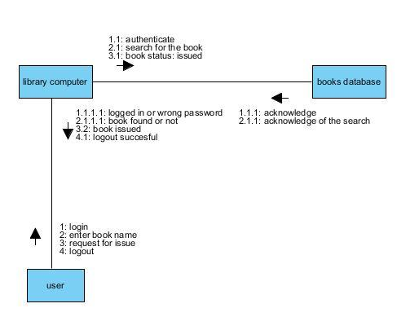

**State Diagram**

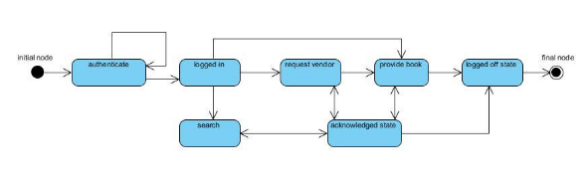

**Data Flow Diagram**

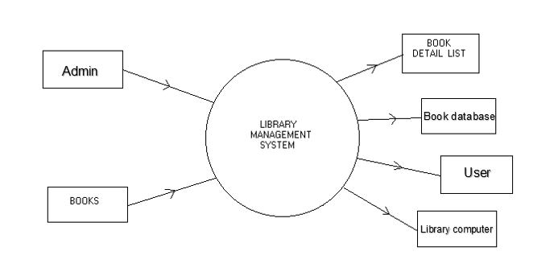

**Architecture Diagram**

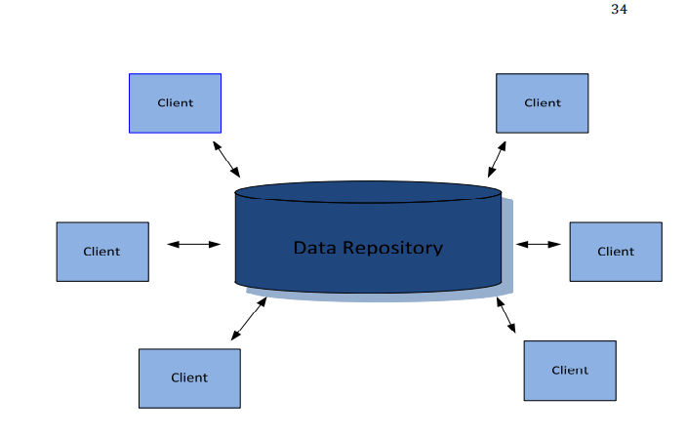

**Implementation:**

**4**

**4.1 Tools/ Technology Used**

* The Basic Codding Language is **HTML.**
* For designing purpose **CSS** is used.
* Core **PHP** is used for connecting with database and server.
* The Client side scripting language will be **JavaScript.**
* For Responsive Design and Increase Browser Compatibility **Bootstrap** is used.
* Database accessing language is **MSQL,** And **SQL**.
* For Documentation **Microsoft Word** is used.

**4.2 Hardware and Software Requirements**

**4.2.1 Hardware Requirements**

The selection of hardware is very important in the existence and proper working of any software. When selecting hardware, the size and requirements are also important.

**Server Side**

PROCESSOR : Intel Pentium core 2 DUO or above

HARD DISK : 60 GB or above

RAM : 1 GB or above

**Client Side**

PROCESSOR : Intel Pentium-III or above

HARD DISK : 40 GB

RAM : 512 MB

**4.2.2 Software Requirements**

The selection of Software is very important in the existence and proper working of any hardware. When selecting hardware or Software, the size and requirements are also important.

**Server Side**

OPERATING SYSTEM : Windows XP or above

SOFTWARE FRAMEWORK : PHP

DATABASE SOFTWARE : My SQL

WEB SERVER : Apache (Xaamp 3.2.3)

**Client Side**

OPERATINGSYSTEM : Windows XP or above

WEB BROWSER : Microsoft Internet Explorer

(Equally compatible or above)

**4.3 Project Screenshots**

**Admin Login**

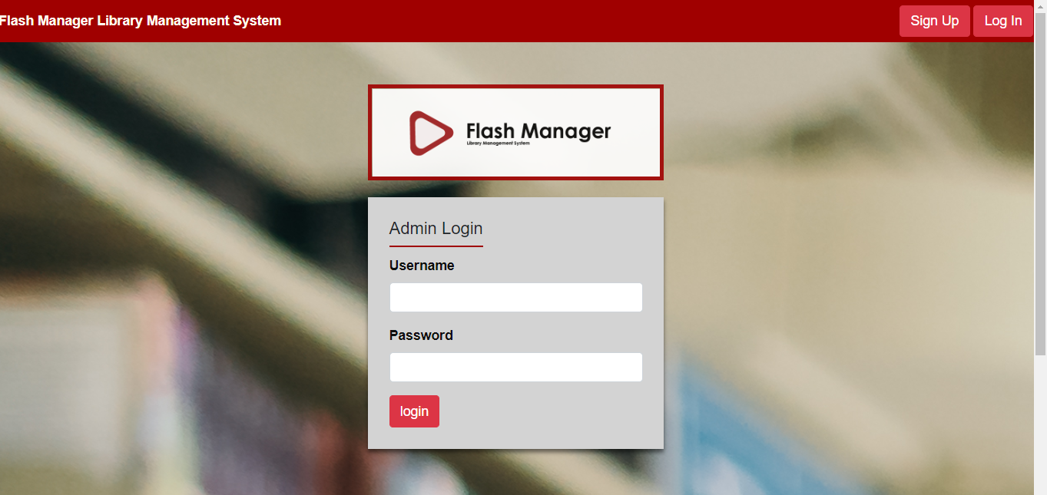

**Admin Dashboard**

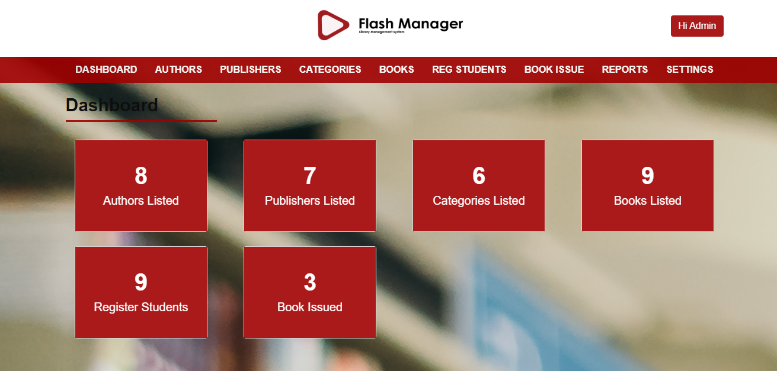

**Authors Page**

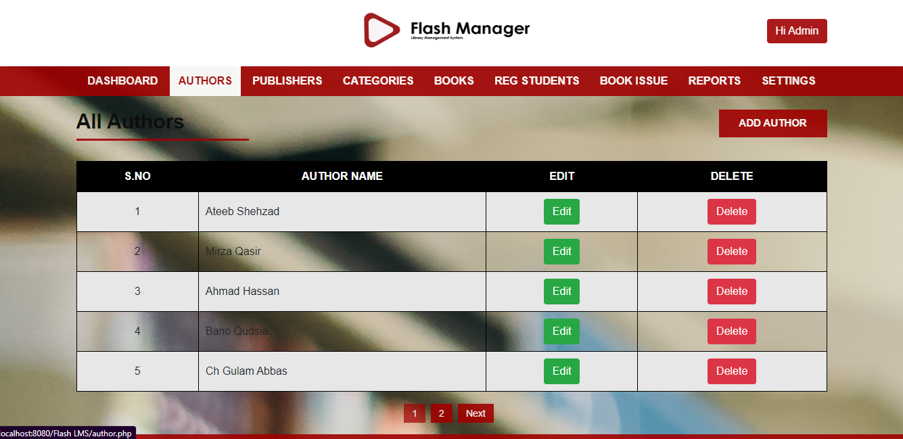

**Edit/Update Author**

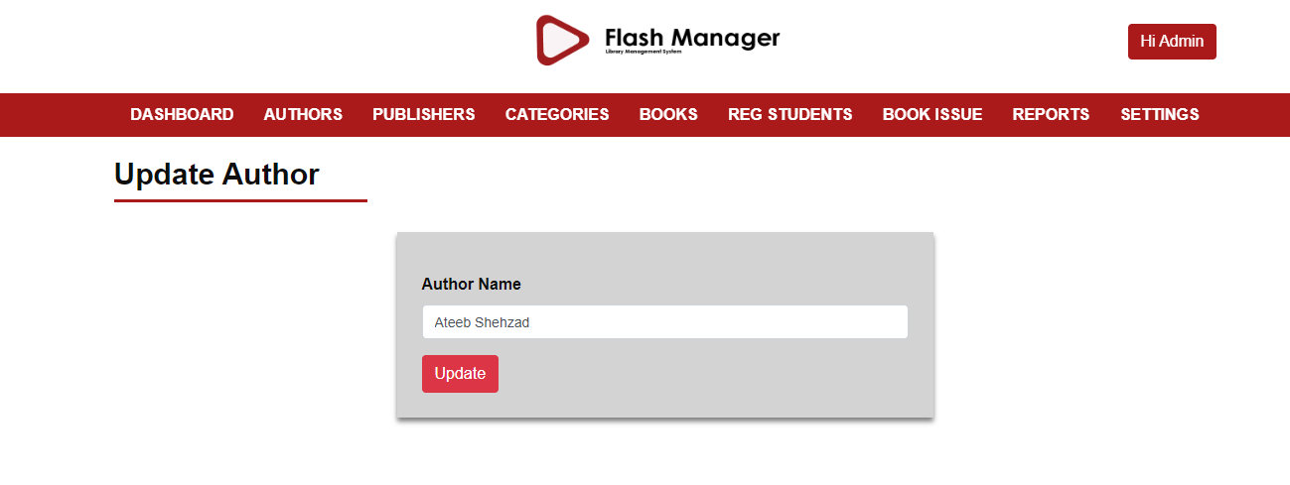

**Adding New Author**

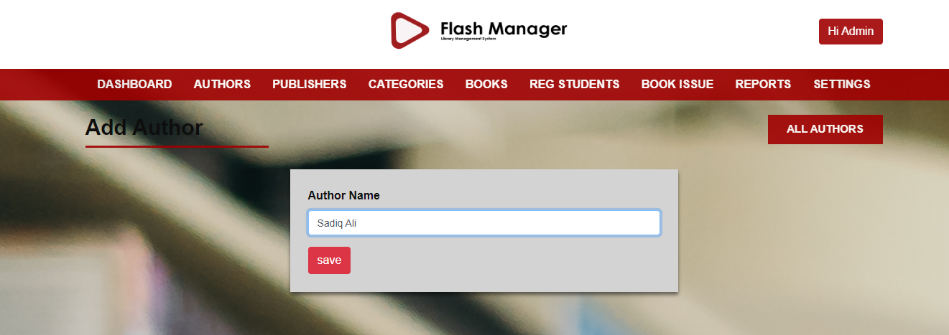

**Publishers Page**

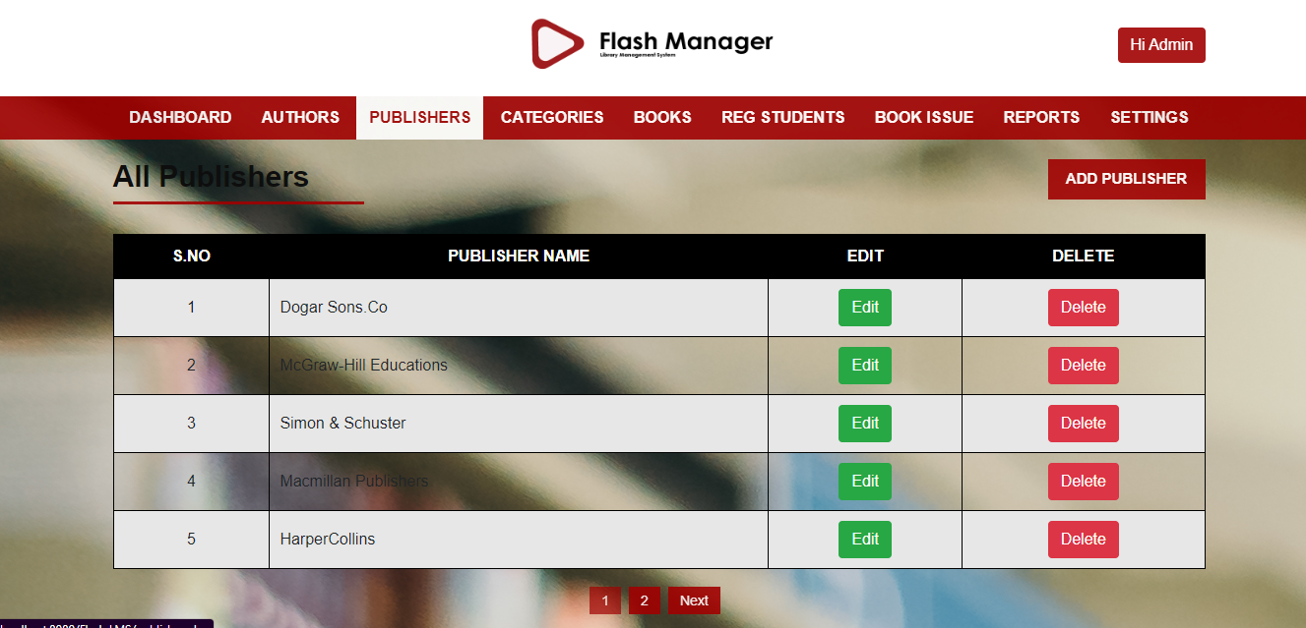

**Edit/Update Publisher**

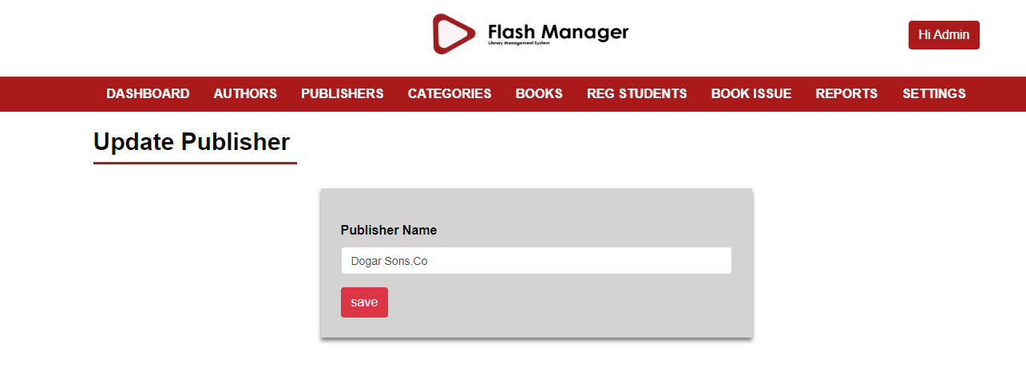

**Adding New Publisher**

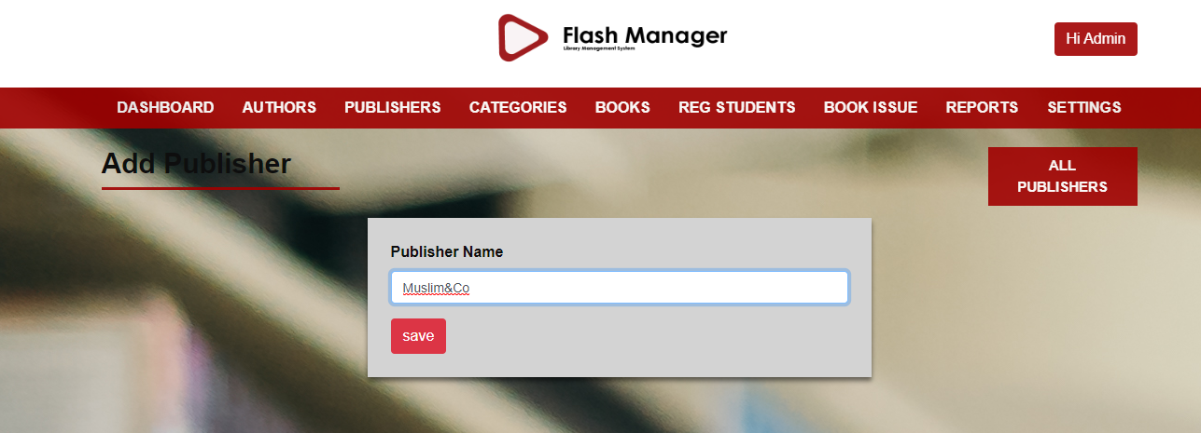

**Categories Page**

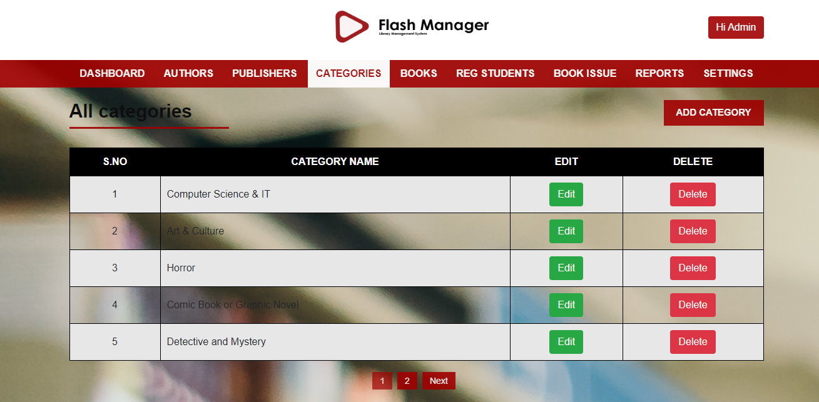

**Edit/Update Category**

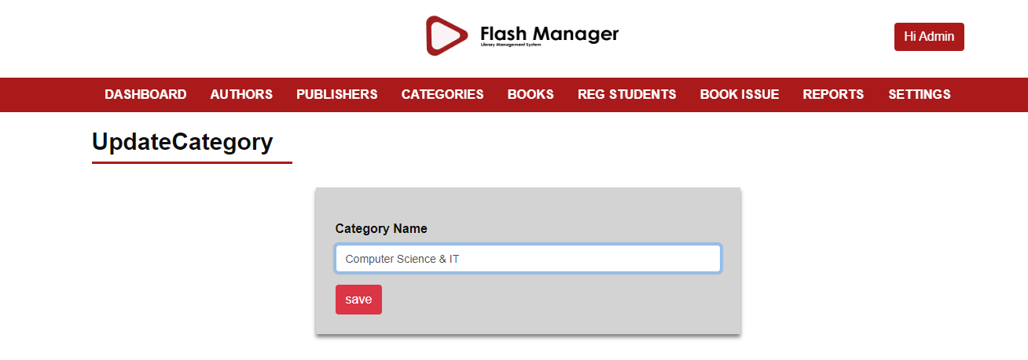

**Adding New Category**

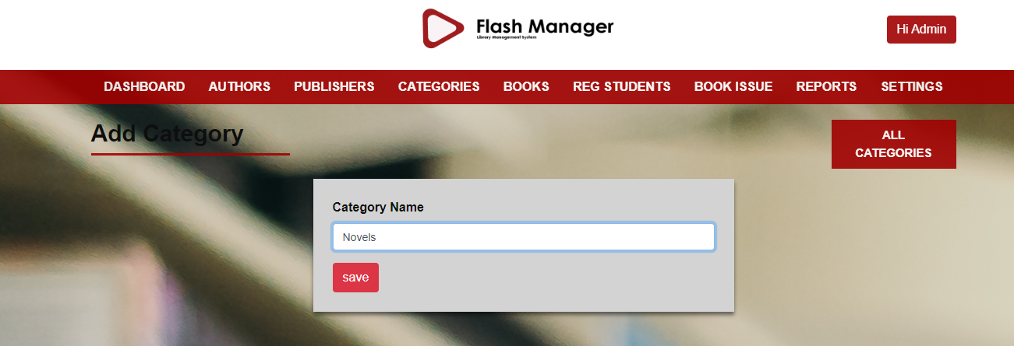

**Books Page**

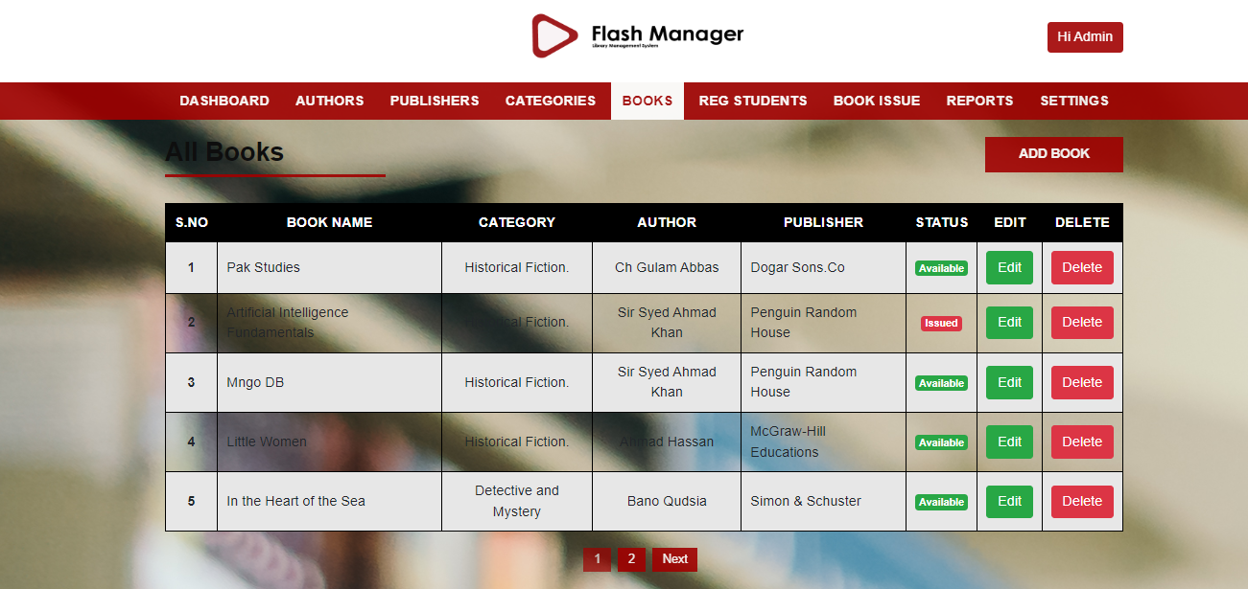

**Edit/Update Book**

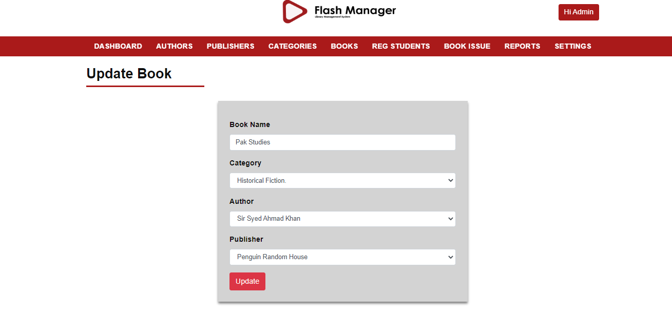

**Adding New Book**

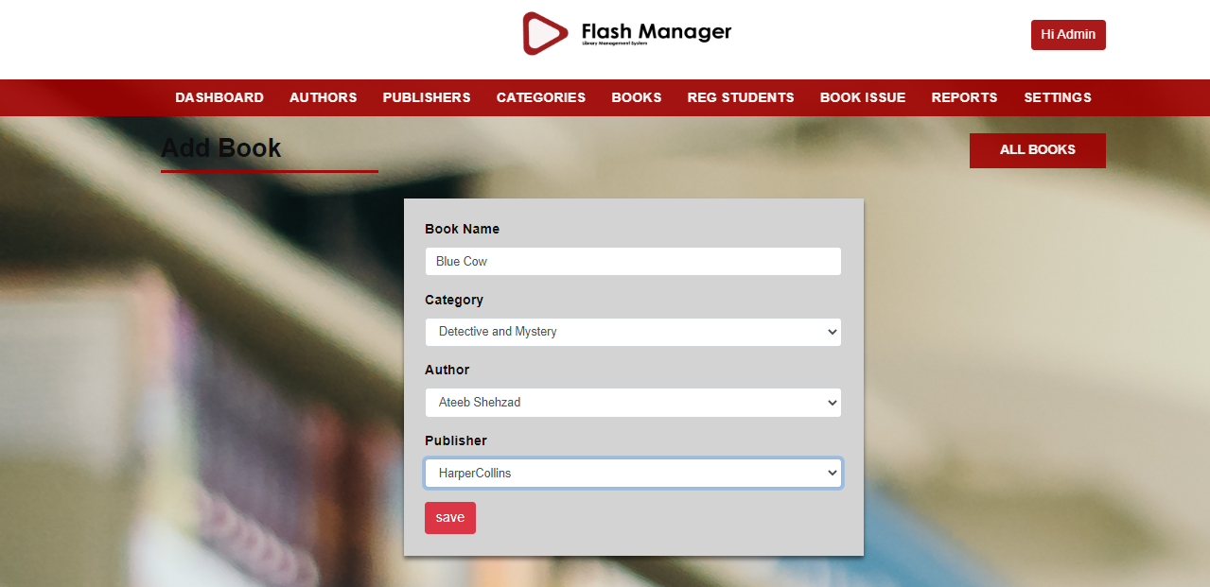

**Student Registration Page**

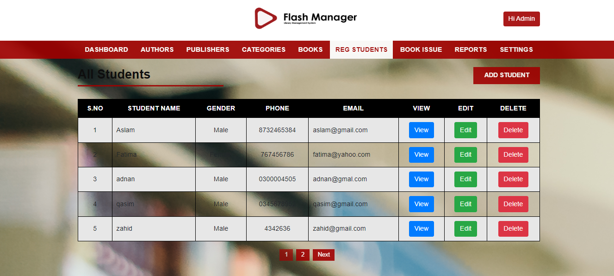

**Adding New Student**

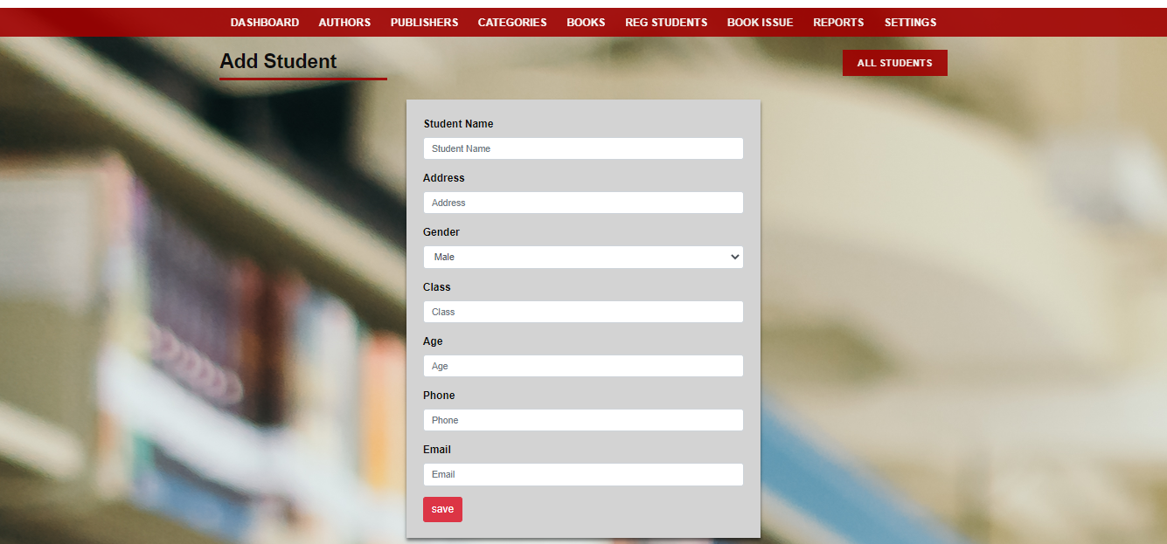

**Book Issue Page**

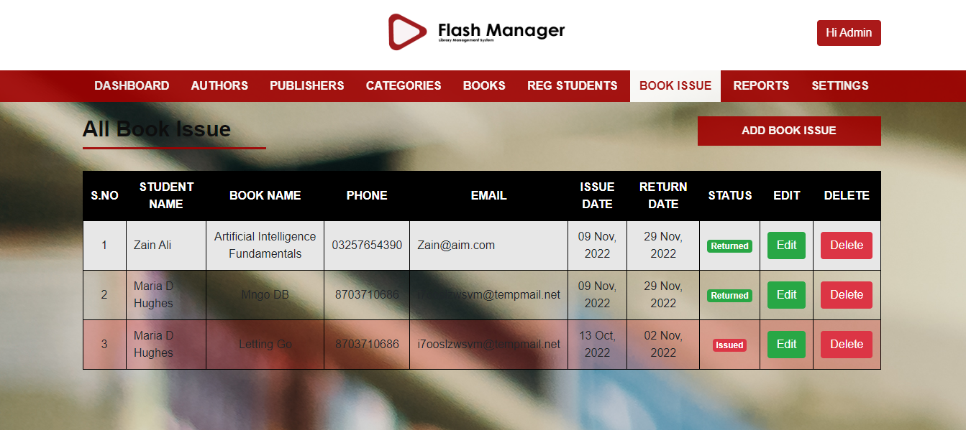

**Issuing a Book**

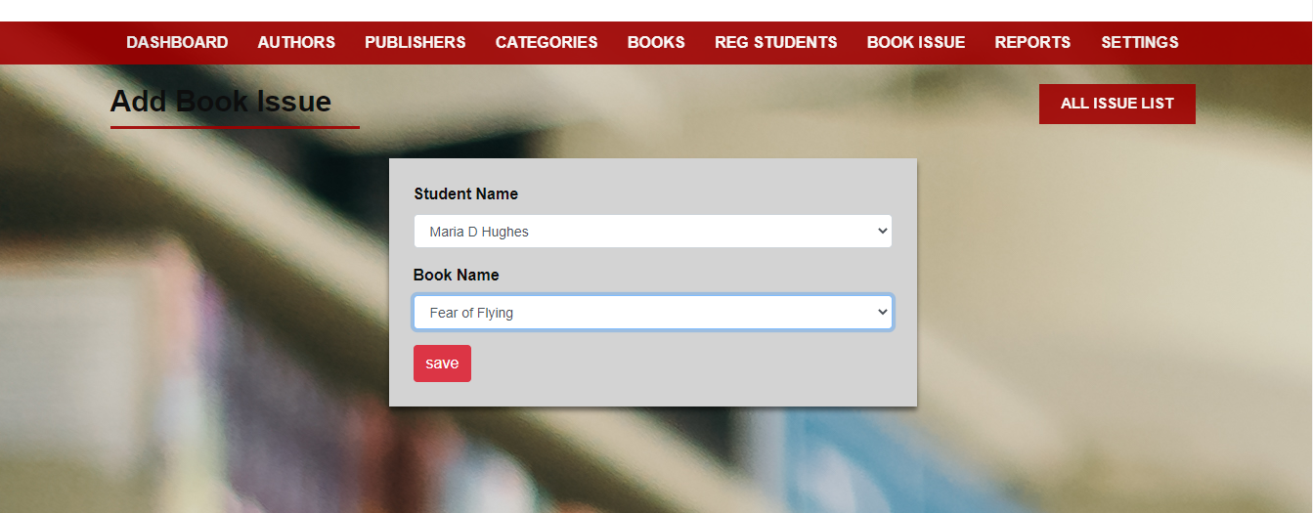

**Returning a Book**

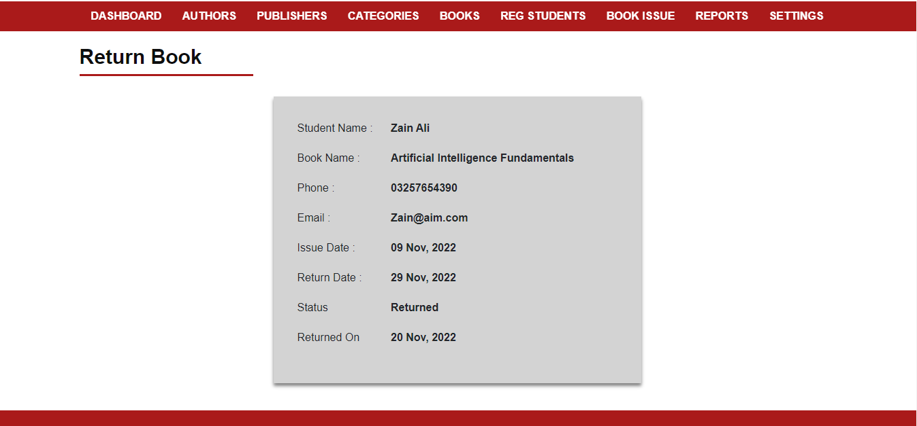

**Reports Page**



**Settings Page**

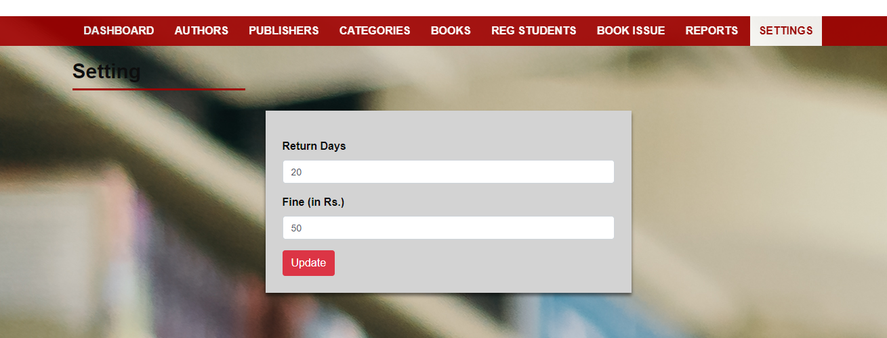

**Student Sign Up**

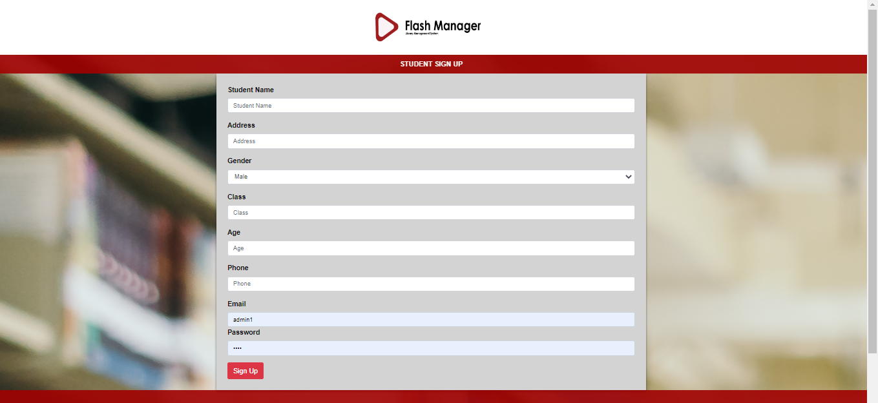

**Student Login**

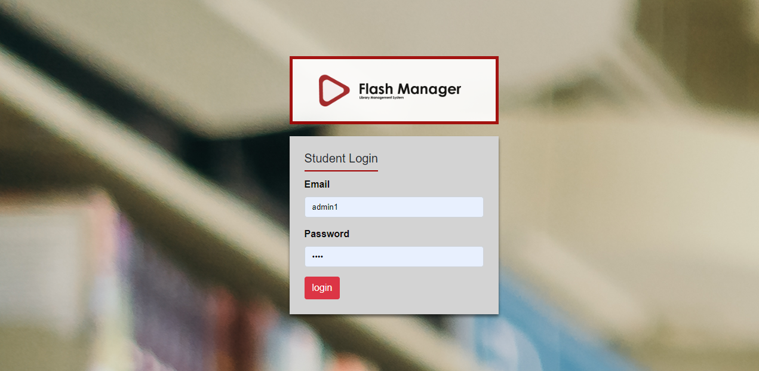

**Student Page**

